## "Cosmetic Insights – Navigating Cosmetics Trends and Consumer Insights with Tableau".

**🧾 1. INTRODUCTION**

**1.1 Project Overview**

The "Cosmetic Insights" project uses Tableau to visualize, analyze, and extract meaningful trends from a cosmetics dataset. It focuses on consumer preferences, product suitability for skin types, and brand comparisons. The platform helps both cosmetic companies and consumers make informed decisions based on data.

**1.2 Purpose**

To provide a centralized data visualization dashboard that helps:

* Identify top brands
* Analyze product suitability for various skin types
* Observe pricing trends
* Evaluate product rankings  
  This promotes better marketing strategies and informed customer choices.

**💡 2. IDEATION PHASE**

**2.1 Problem Statement**

Cosmetic buyers and companies often lack visual tools to understand how their products are performing across skin types, price ranges, and customer satisfaction. There is no clear way to monitor this data in real-time to make product or marketing adjustments.

**2.2 Empathy Map Canvas**

| **Section** | **Insights** |
| --- | --- |
| **Think & Feel** | “Is this product right for my skin?” “Is it worth the price?” |
| **Hear** | Influencer opinions, online reviews, dermatologist suggestions |
| **See** | A wide variety of brands and products with unclear benefits |
| **Say & Do** | Search for product reviews, compare brands, ask friends |
| **Pains** | Product not suitable for skin, expensive, causes irritation |
| **Gains** | Reliable, skin-type-specific recommendations and affordable pricing |

**2.3 Brainstorming**

* What visual charts are useful? (pie chart, bar chart, box plot, bubble chart)
* How can we show skin suitability?
* Can we embed dashboards in a website?
* How to show product rankings vs labels?
* What metrics can define “top brands”?

**📊 3. REQUIREMENT ANALYSIS**

**3.1 Customer Journey Map**

| **Step** | **Action** |
| --- | --- |
| 1 | User searches for cosmetic products suitable for their skin |
| 2 | They check brand reputation and product reviews |
| 3 | They compare price and rank |
| 4 | They choose a product based on insights |

**3.2 Solution Requirement**

* A clean CSV dataset
* Tableau Desktop or Tableau Public
* Internet for web embedding (Tableau Public or Flask)
* Laptop/PC for building and testing dashboards

**3.3 Data Flow Diagram**

CSV Dataset

↓

Data Cleaning & Import in Tableau

↓

Visualizations (Charts, Dashboards, Stories)

↓

Embedded in Web App using Flask / Tableau Public

**3.4 Technology Stack**

| **Layer** | **Tools/Tech Used** |
| --- | --- |
| Data Layer | CSV file (cosmetics dataset) |
| Visualization | Tableau |
| Frontend (optional) | Flask + HTML/CSS |
| Deployment | Tableau Public / Local Web Server |
| File Sharing | Google Drive, GitHub |

**🛠️ 4. PROJECT DESIGN**

**4.1 Problem Solution Fit**

The visualization project directly addresses the need for:

* Product comparison by skin suitability
* Price and rank comparison by brand
* Easy-to-understand insights for both companies and customers

**4.2 Proposed Solution**

Create an interactive set of visualizations that:

* Show top brands and product types
* Compare price and rank per brand
* Show skin suitability in charts (bar, bubble, box plot)
* Combine all in a dashboard and story view

**4.3 Solution Architecture**

CSV Dataset

↓

Tableau

↓

Visualizations (9+)

↓

Dashboards (2) + Story (1)

↓

Embed via Tableau Public or Flask Web App

**🗓️ 5. PROJECT PLANNING & SCHEDULING**

**5.1 Project Planning Table**

| **Phase** | **Task** | **Time (Days)** |
| --- | --- | --- |
| Phase 1 | Dataset Collection | 1 |
| Phase 2 | Data Cleaning & Loading | 1 |
| Phase 3 | Visualization Creation | 2 |
| Phase 4 | Dashboard & Story Design | 1 |
| Phase 5 | Performance Testing | 1 |
| Phase 6 | Web Integration & Demo | 1 |
| Phase 7 | Documentation & Report Writing | 1 |

**⚙️ 6. FUNCTIONAL AND PERFORMANCE TESTING**

**6.1 Performance Testing**

* **Amount of Data Loaded:** 309 records
* **Data Filters:** Used on skin types and brand fields
* **Calculation Fields:** Price range bins, count per label, ranking conversion
* **Number of Visualizations:** 9+ (Top Brands, Label Count, Price vs Brand, etc.)
* **Test Result:** Smooth performance with real-time interaction; no lags observed.

**🖥️ 7. RESULTS**

**7.1 Output Screenshots**

* Pie Chart: Top Brands

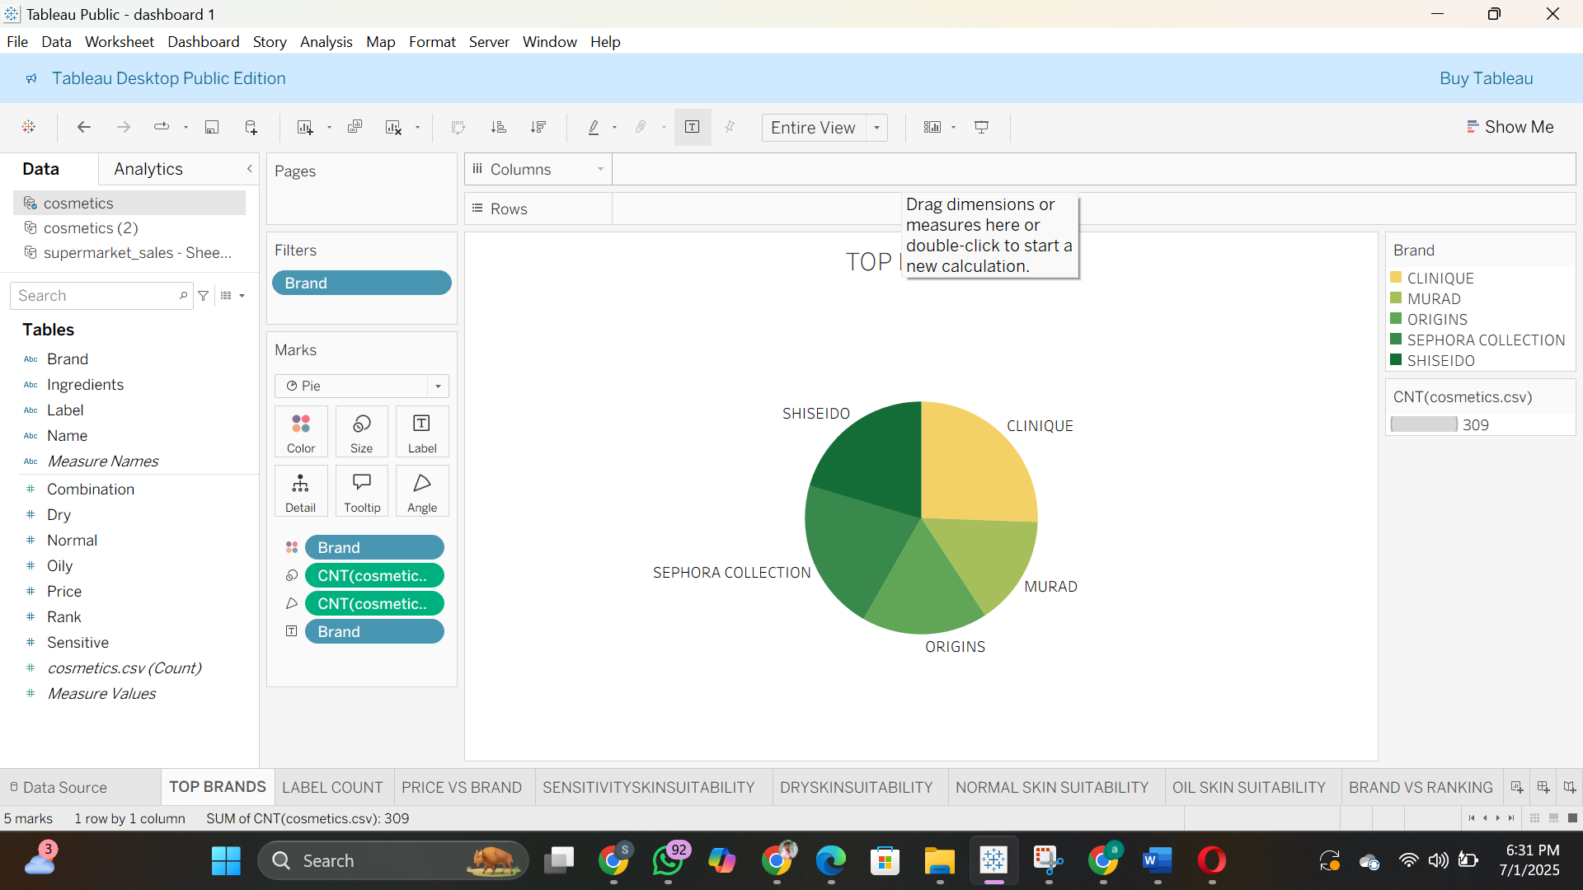

* Bar Chart: Label Count

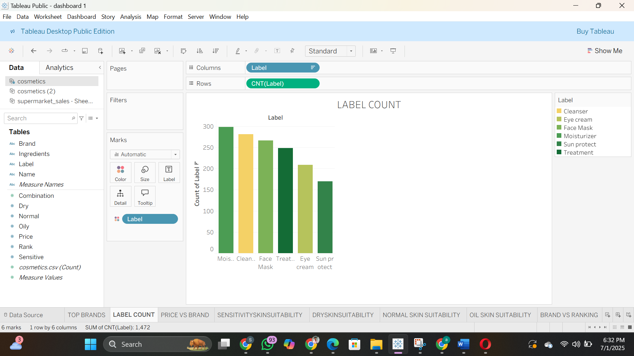

* Box Plot: Price vs Brand

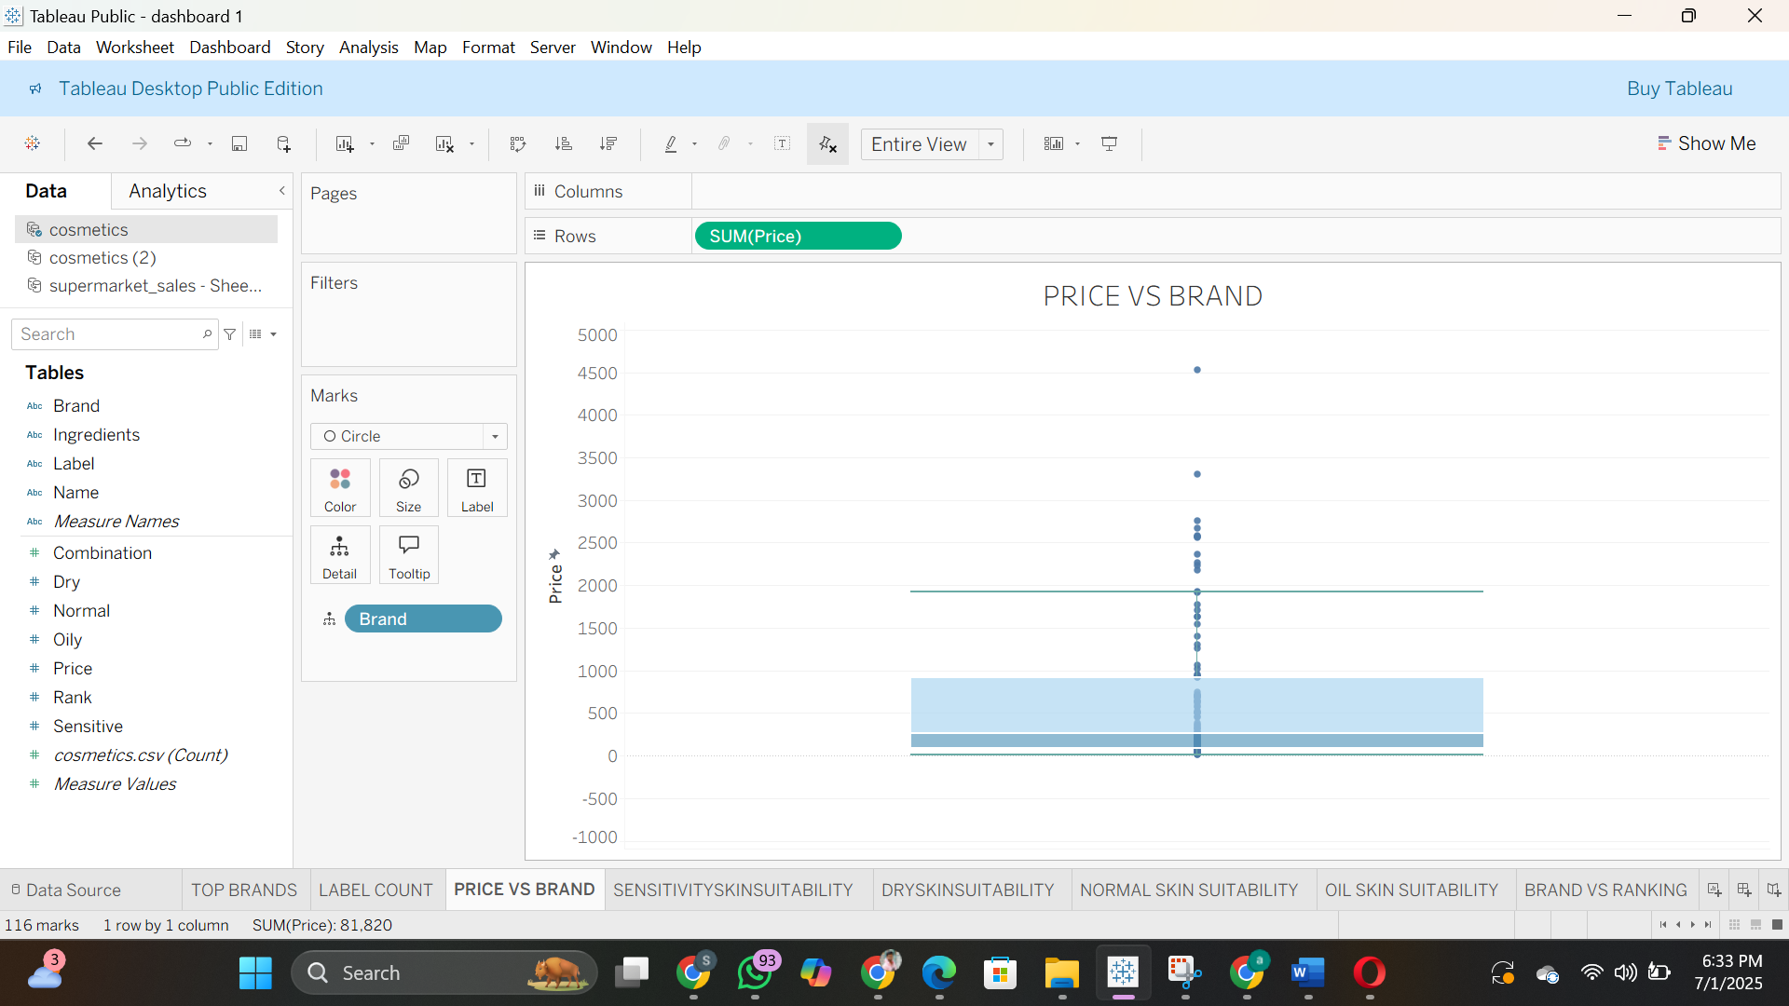

* Grouped Bars: Sensitive Skin Suitability

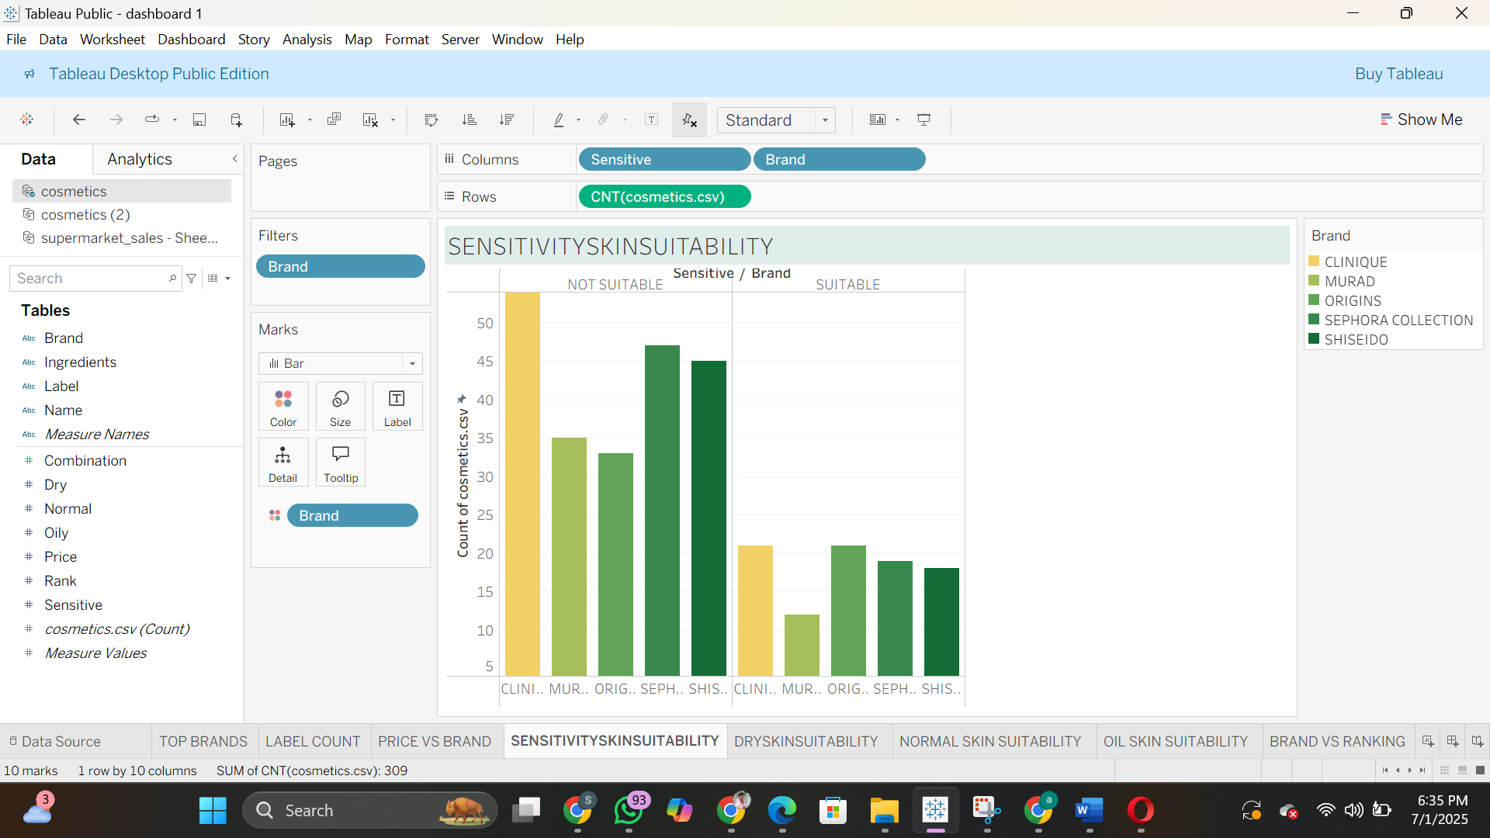

* Packed Bubbles: Dry Skin Suitability

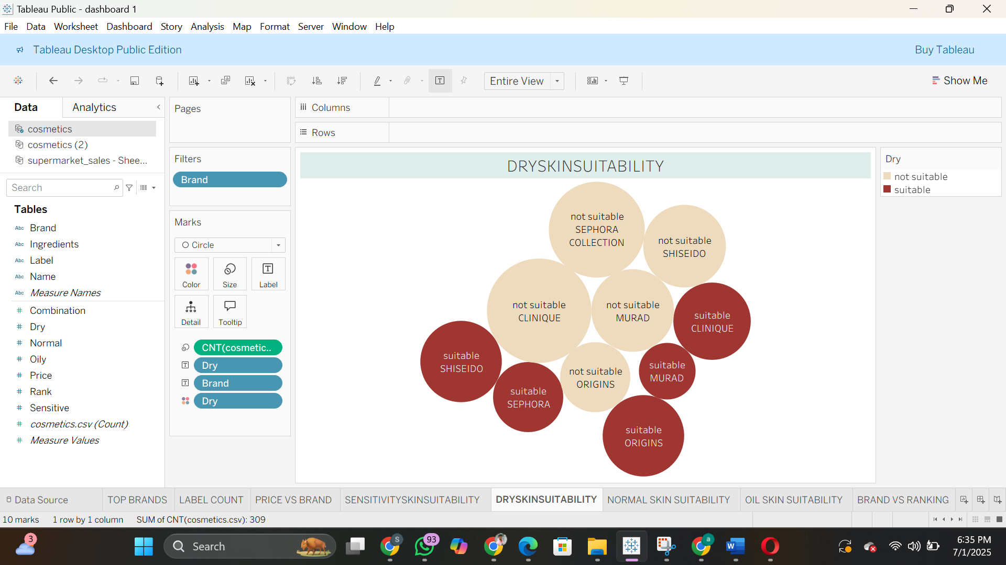

* Box Plot: Normal Skin Suitability

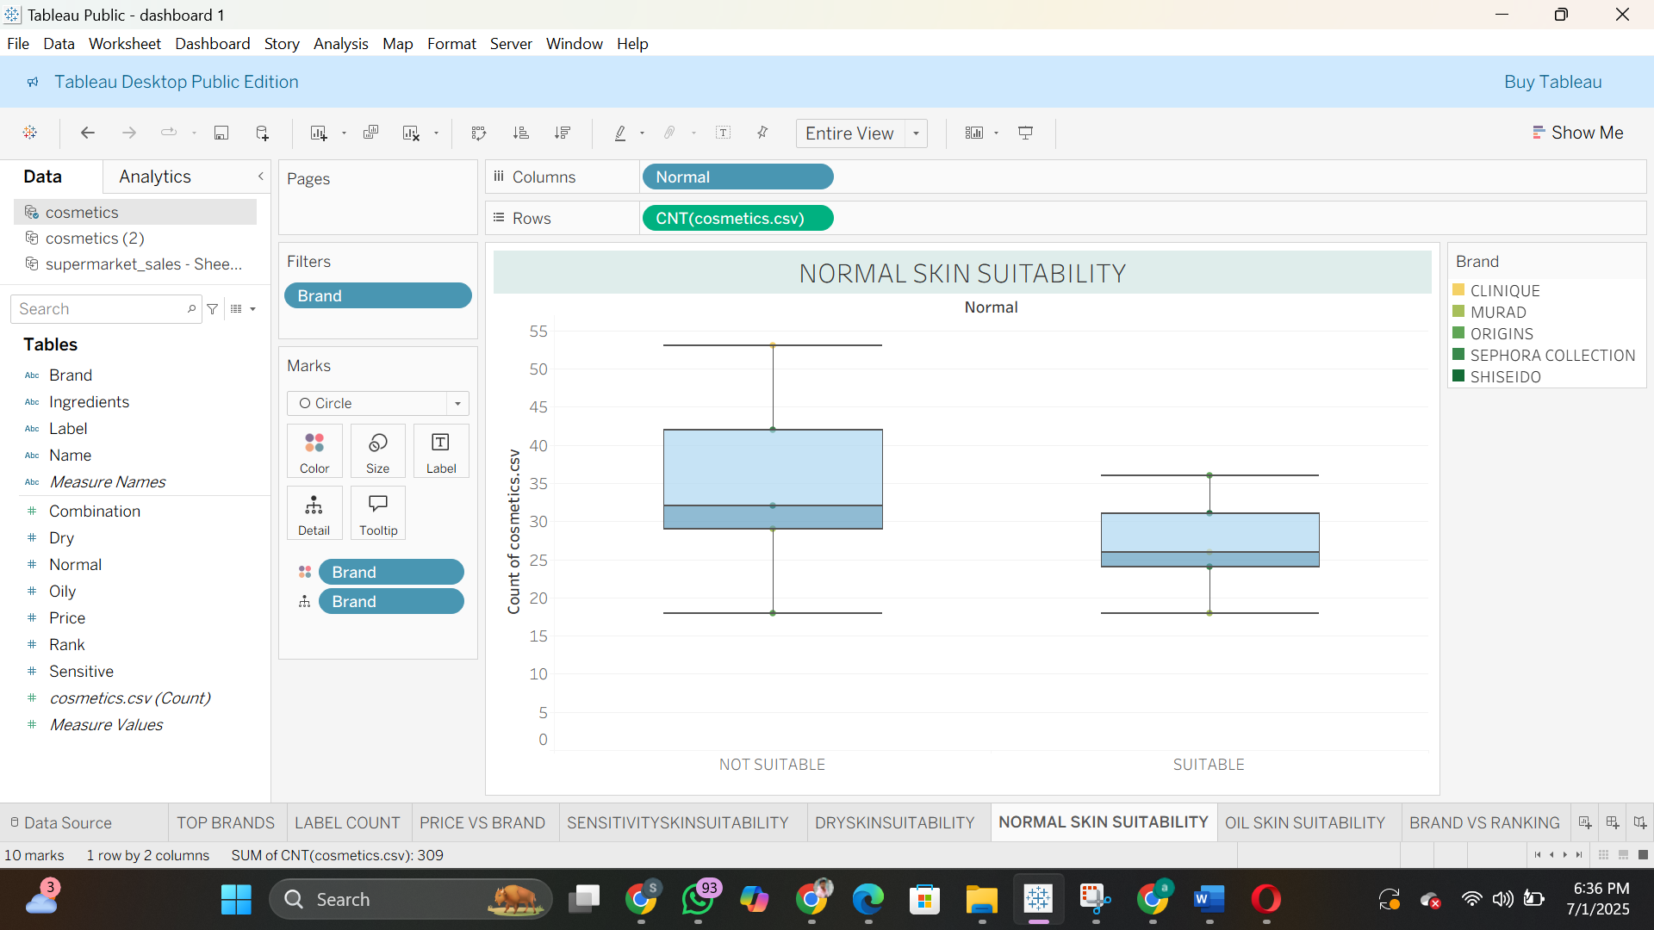

* Stacked Bars: Oily Skin Suitability

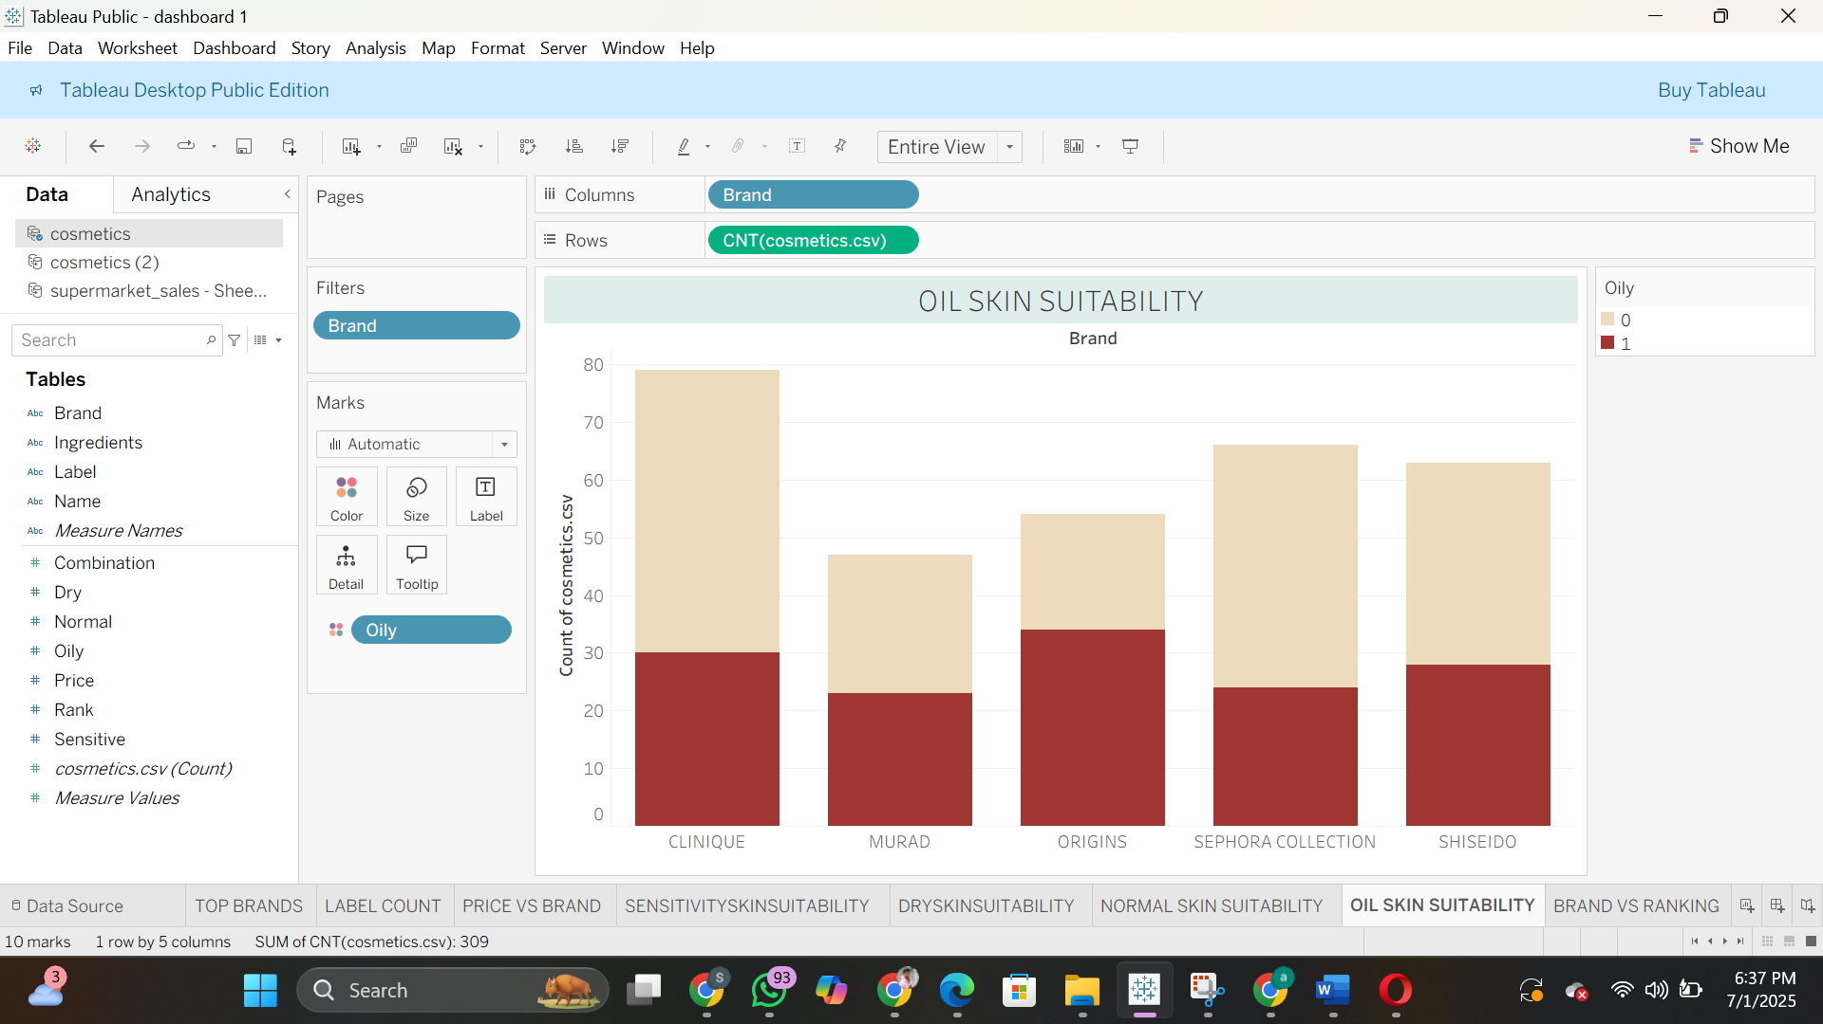

* Bar Chart: Brand vs Ranking

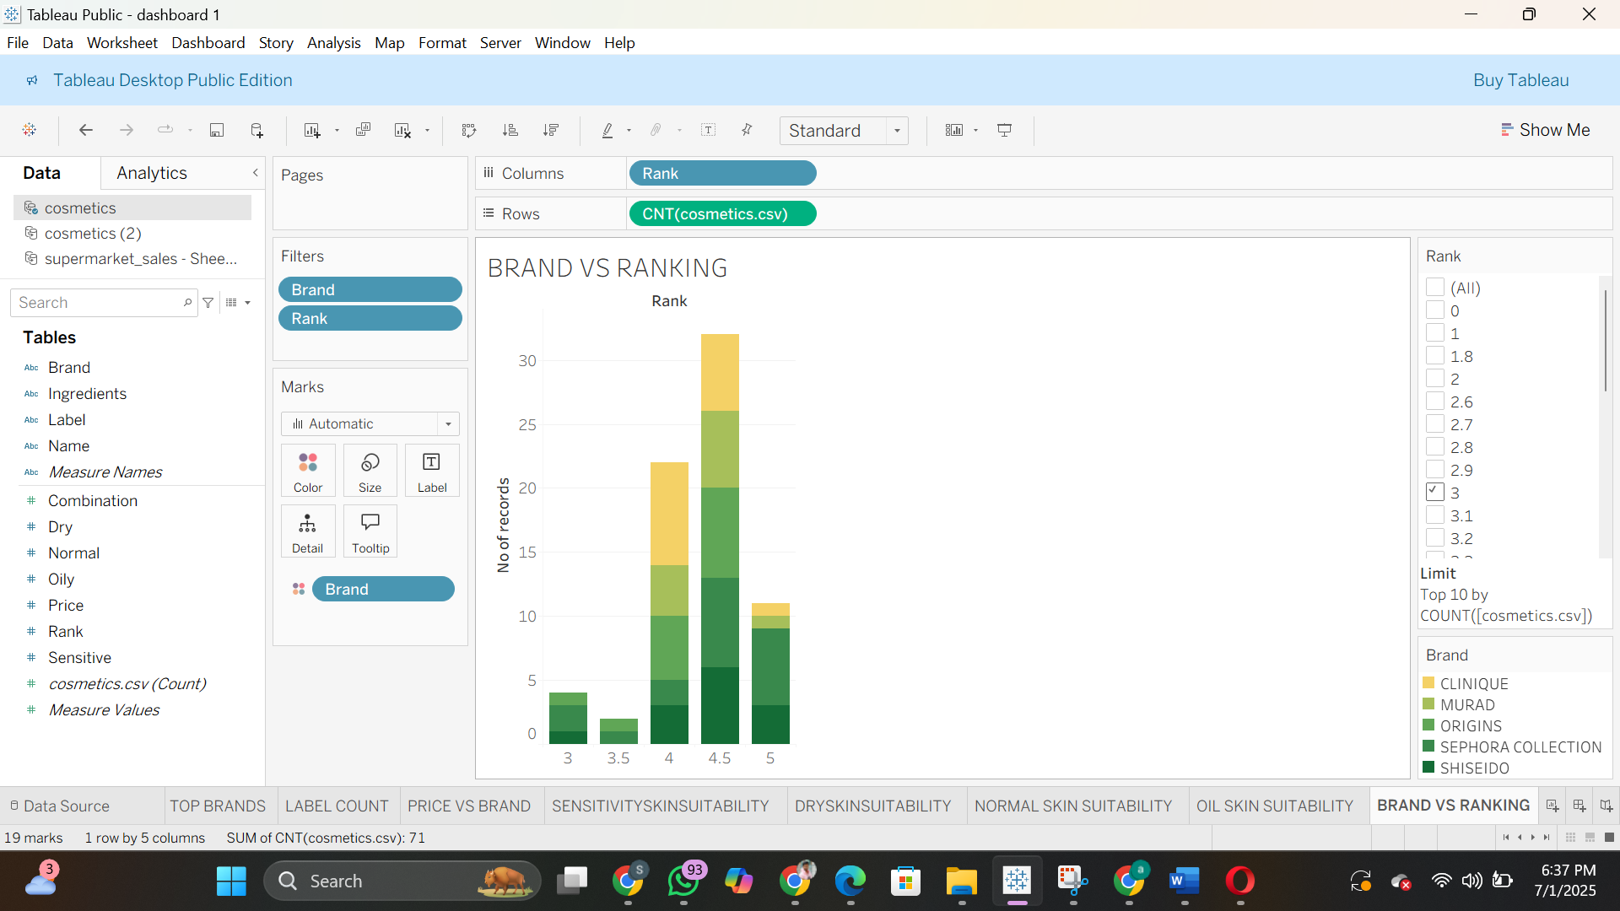

* Bar Chart: Label vs Ranking

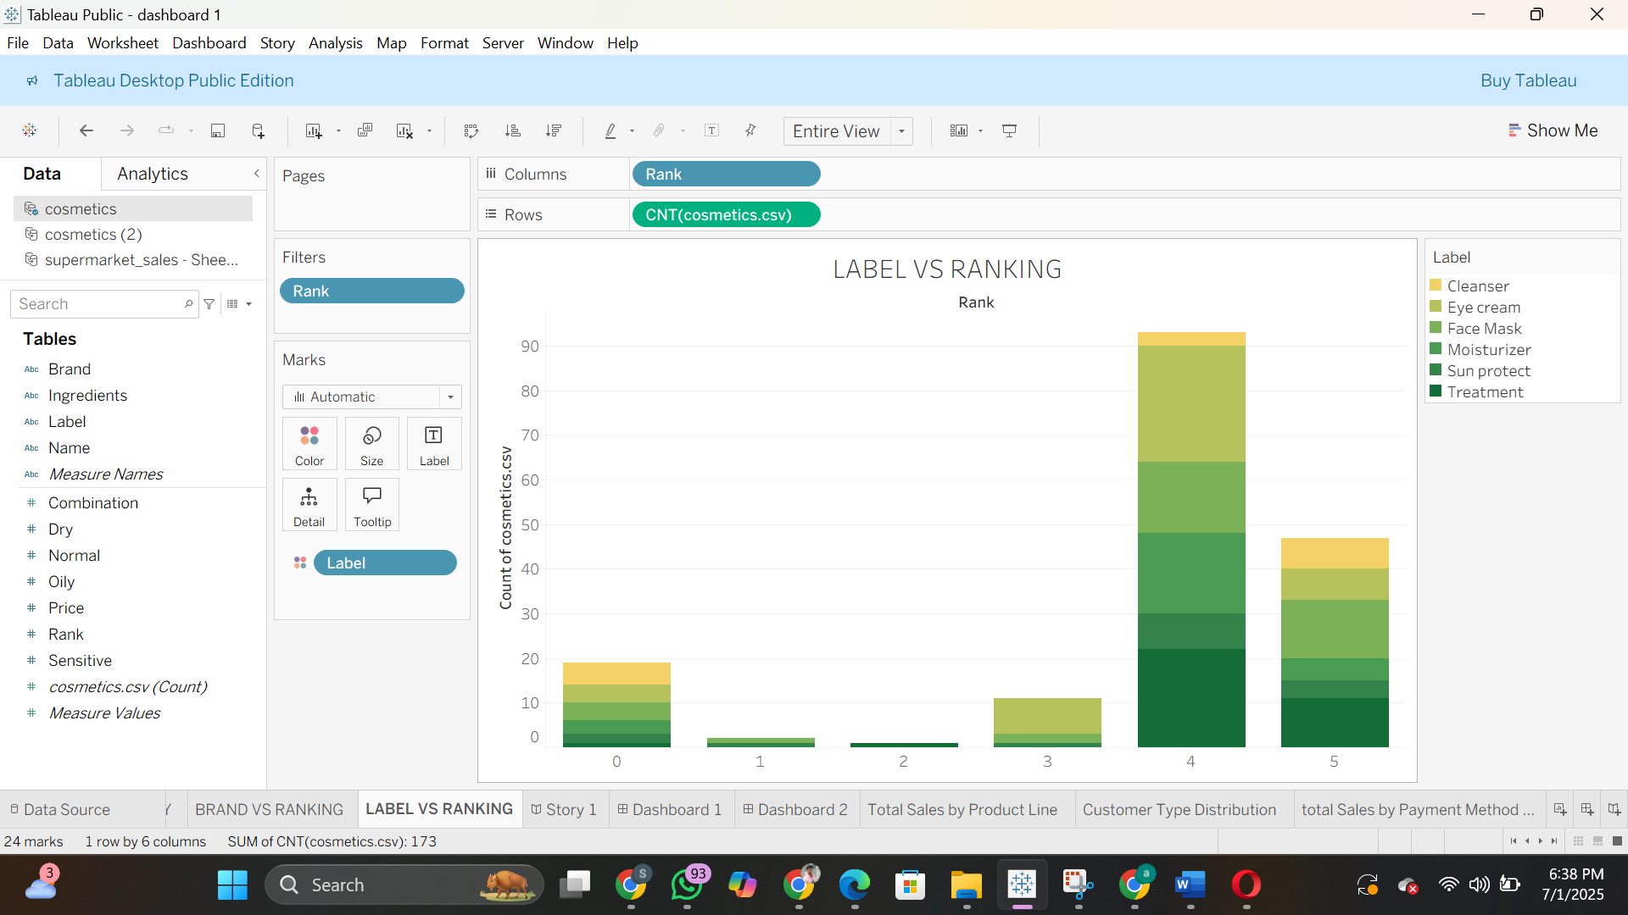

* Dashboard 1: Product Suitability Overview

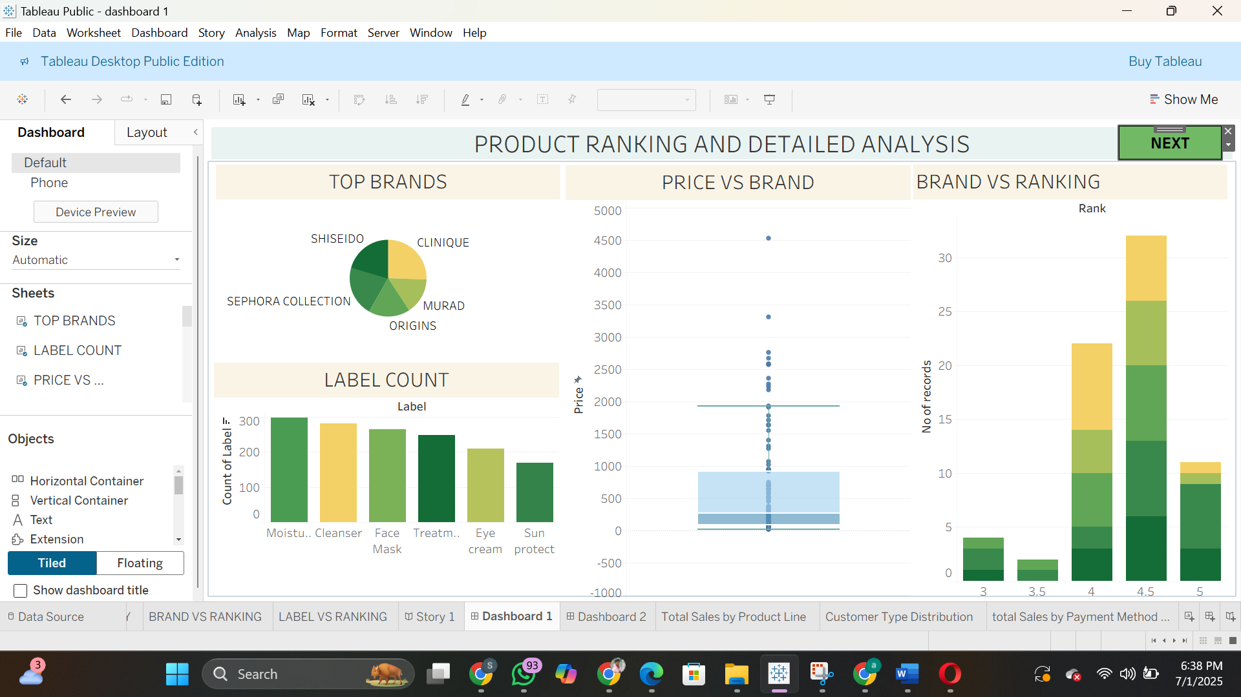

* Dashboard 2: Ranking Overview

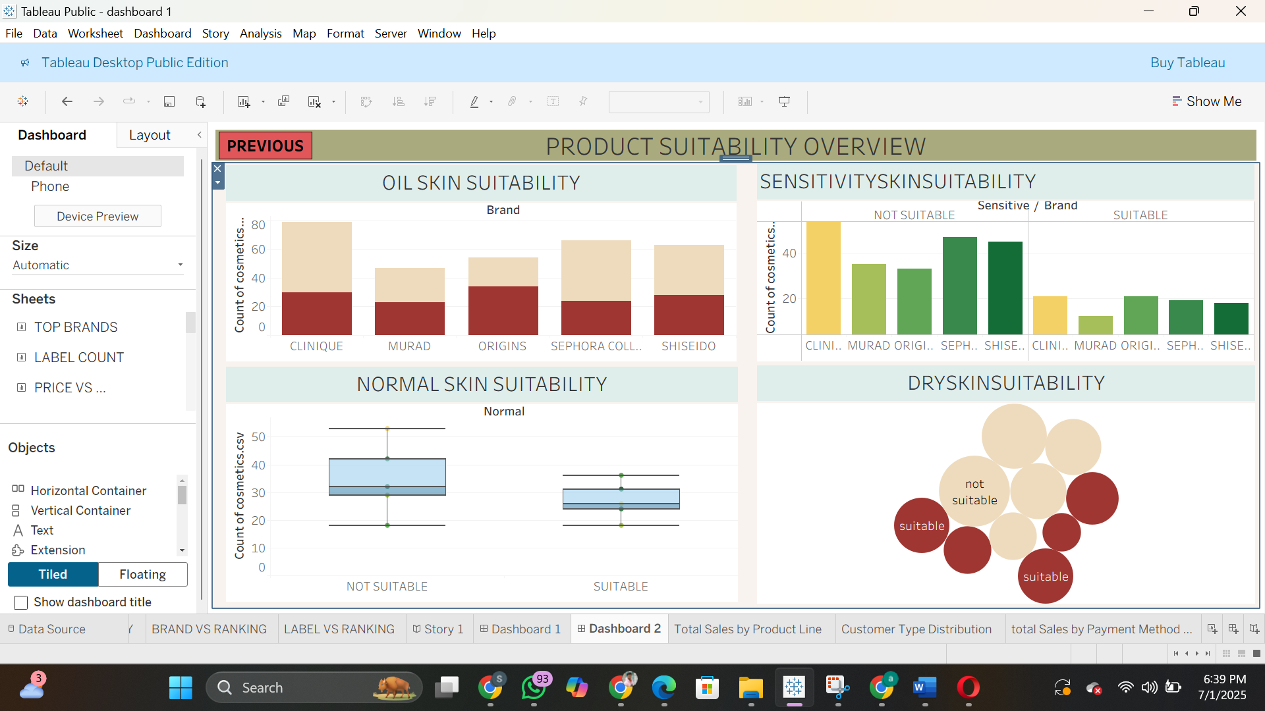

* Story: Combined Narrative Flow of Insights

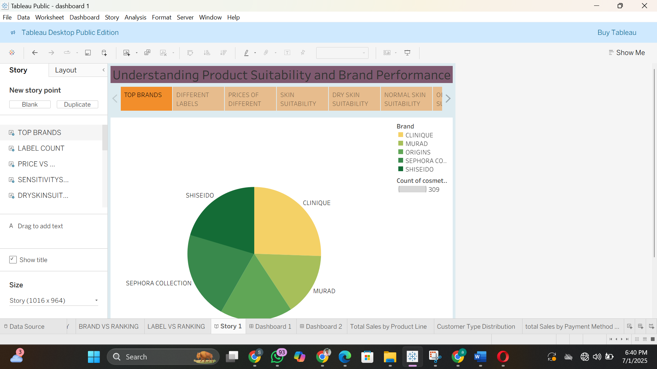

**✅ 8. ADVANTAGES & DISADVANTAGES**

**Advantages**

* Easy to use and interpret
* Real-time consumer insights
* Customizable dashboards
* Supports proactive business decisions

**Disadvantages**

* Requires Tableau software knowledge
* Doesn’t handle live data feeds
* Limited scalability for big data volumes

**🔚 9. CONCLUSION**

The Cosmetic Insights project successfully demonstrates the use of data visualization tools like Tableau to analyze cosmetic product trends. It simplifies the understanding of consumer behavior, price comparisons, and brand positioning, supporting better product decisions in the beauty industry.

**🚀 10. FUTURE SCOPE**

* Add live API for real-time product data
* Integrate customer review analysis using NLP
* Build a product recommendation engine
* Add mobile-responsive dashboards

**📎 11. APPENDIX**

**Source Code:**

**Flask file:**

from flask import Flask, render_template

app = Flask(__name__)

@app.route('/')

def index():

return render_template('index.html')

if __name__ == '__main__':

app.run(debug=True)

**HTML AND CSS CODE:**

<!DOCTYPE html>

<html lang="en">

<head>

<meta charset="UTF-8" />

<title>Cosmetics Analysis - Full Site</title>

<meta name="viewport" content="width=device-width, initial-scale=1" />

<link href="https://cdn.jsdelivr.net/npm/bootstrap@5.3.0/dist/css/bootstrap.min.css" rel="stylesheet">

<script src="https://cdn.jsdelivr.net/npm/chart.js"></script>

<script src="https://kit.fontawesome.com/a076d05399.js" crossorigin="anonymous"></script>

<link href="https://fonts.googleapis.com/css2?family=Open+Sans:wght@400;600&display=swap" rel="stylesheet">

<style>

body {

font-family: 'Open Sans', sans-serif;

background-color: #f5f5f5;

color: #333;

}

.navbar, .header {

background-color: #000;

color: #fff;

padding: 15px 20px;

}

.navbar a {

color: #fff;

margin-left: 15px;

text-decoration: none;

}

.navbar a:hover, .navbar a.active {

border-bottom: 2px solid #00c3a5;

}

.hero-section {

background: linear-gradient(to right, #2c3e50, #3498db);

color: white;

padding: 60px 20px;

text-align: center;

}

.hero-section h2 {

font-size: 36px;

margin-bottom: 20px;

}

.hero-section p {

font-size: 18px;

max-width: 600px;

margin: 0 auto;

}

.section {

padding: 60px 20px;

}

.chart-container {

display: flex;

flex-wrap: wrap;

gap: 20px;

margin-top: 20px;

}

.chart-box {

flex: 1 1 45%;

padding: 20px;

background-color: #fff;

box-shadow: 0 2px 8px rgba(0,0,0,0.1);

border-radius: 8px;

}

.insights {

background-color: #e0f7fa;

padding: 20px;

border-radius: 8px;

}

footer {

background-color: #f8f9fa;

text-align: center;

padding: 20px;

}

canvas {

width: 100% !important;

height: 300px !important;

}

.gallery img {

width: 100%;

height: auto;

border-radius: 8px;

box-shadow: 0 2px 6px rgba(0,0,0,0.1);

}

</style>

</head>

<body>

<!-- Navbar -->

<div class="navbar d-flex justify-content-between">

<h2 class="text-white">COSMETICS ANALYSIS</h2>

<div>

<a href="#home" class="active">Home</a>

<a href="#about">About</a>

<a href="#dashboard">Dashboard</a>

<a href="#story">Story</a>

<a href="#insights">Insights</a>

</div>

</div>

<!-- Home Section -->

<section id="home" class="hero-section">

<h2>Welcome to Your Skincare Companion</h2>

<p>Find the best products tailored to your unique skin type using data-driven analysis and expert insights.</p>

</section>

<section id="feature-image" style="padding: 0; margin: 0;">

<img

src="https://i.postimg.cc/d1XzNCrp/Screenshot-2025-06-27-090601.png"

alt="Feature"

style="width: 100%; height: auto; display: block;"

/>

</section>

<!-- About Section -->

<!-- ✅ Updated About Section with Image on Left and Maximized -->

<section id="about" style="padding: 80px 20px; background-color: #fff; font-family: 'Segoe UI', sans-serif;">

<div class="container" style="max-width: 1200px; margin: auto; display: flex; flex-wrap: wrap; align-items: center; gap: 40px;">

<!-- Left Side: Large Image -->

<div style="flex: 1 1 50%; text-align: center;">

<img src="https://i.postimg.cc/rFCsrjg8/download.jpg"

alt="Skincare Products"

style="width: 100%; max-width: 100%; border-radius: 12px; box-shadow: 0 8px 24px rgba(0,0,0,0.1);" />

</div>

<!-- Right Side: Text & Features -->

<div style="flex: 1 1 45%;">

<h2 style="font-size: 32px; color: #1a2d44; font-weight: 700; margin-bottom: 15px;">

Discover Your Perfect Skincare

</h2>

<p style="font-size: 17px; color: #666; margin-bottom: 40px;">

Find the best products for your skin with our expert analysis and personalized recommendations.

</p>

<div style="display: flex; flex-direction: column; gap: 20px;">

<div style="display: flex; gap: 15px;">

<i class="fas fa-file-alt" style="color: #00c2c2; font-size: 24px;"></i>

<div>

<h4 style="margin: 0; font-size: 18px; color: #1a2d44;">Tailored for You</h4>

<p style="margin: 0; color: #555;">Products that match your unique skin type and goals.</p>

</div>

</div>

<div style="display: flex; gap: 15px;">

<i class="fas fa-lightbulb" style="color: #00c2c2; font-size: 24px;"></i>

<div>

<h4 style="margin: 0; font-size: 18px; color: #1a2d44;">Easy and Informative</h4>

<p style="margin: 0; color: #555;">Simple, jargon-free skincare advice.</p>

</div>

</div>

<div style="display: flex; gap: 15px;">

<i class="fas fa-thumbs-up" style="color: #00c2c2; font-size: 24px;"></i>

<div>

<h4 style="margin: 0; font-size: 18px; color: #1a2d44;">Trusted Recommendations</h4>

<p style="margin: 0; color: #555;">Expert-curated insights for better decisions.</p>

</div>

</div>

<div style="display: flex; gap: 15px;">

<i class="fas fa-arrow-circle-up" style="color: #00c2c2; font-size: 24px;"></i>

<div>

<h4 style="margin: 0; font-size: 18px; color: #1a2d44;">Start Your Journey</h4>

<p style="margin: 0; color: #555;">Explore what truly works for your skin.</p>

</div>

</div>

</div>

</div>

</div>

</section>

<!-- Additional sections like Dashboard, Story, and Insights go here... -->

<!-- Dashboard Section -->

<section id="dashboard" class="section">

<h2 class="text-center">Dashboard</h2>

<div class="container chart-container">

<div class="chart-box">

<h5>Product Suitability Overview (Tableau Dashboard)</h5>

<div class='tableauPlaceholder' id='viz1' style='position: relative'>

<noscript>

<a href='#'>

<img src='https://public.tableau.com/static/images/da/dashboard1_17509567772040/Dashboard2/1_rss.png' style='border: none' />

</a>

</noscript>

<object class='tableauViz' style='display:none;'>

<param name='host_url' value='https%3A%2F%2Fpublic.tableau.com%2F' />

<param name='embed_code_version' value='3' />

<param name='name' value='dashboard1_17509567772040/Dashboard2' />

<param name='toolbar' value='yes' />

</object>

</div>

</div>

</div>

</section>

<!-- Story Section -->

<section id="story" class="section">

<h2 class="text-center">Story - Understanding Product Suitability</h2>

<div class="container">

<div class='tableauPlaceholder' id='viz2' style='position: relative'>

<noscript>

<a href='#'>

<img src='https://public.tableau.com/static/images/my/mystory_17509575913340/Story1/1_rss.png' style='border: none' />

</a>

</noscript>

<object class='tableauViz' style='display:none;'>

<param name='host_url' value='https%3A%2F%2Fpublic.tableau.com%2F' />

<param name='embed_code_version' value='3' />

<param name='name' value='mystory_17509575913340/Story1' />

<param name='toolbar' value='yes' />

</object>

</div>

</div>

</section>

<!-- Insights Section -->

<section id="insights" class="section" style="padding: 60px 20px; background-color: #ffffff; font-family: Arial, sans-serif;">

<div class="container" style="max-width: 960px; margin: 0 auto;">

<div style="background: linear-gradient(to right, #f0fbfc, #e9fdfb); padding: 30px 25px; border-radius: 12px; box-shadow: 0 4px 10px rgba(0,0,0,0.05);">

<h2 style="font-size: 26px; color: #1d2b44; font-weight: bold; margin-bottom: 20px;">Key Insights</h2>

<p style="margin-bottom: 15px; color: #333;">

<strong>Top Brands:</strong> The leading cosmetics brands are

<a href="#" style="color: #00a3c4; text-decoration: none;">Clinique</a> and

<a href="#" style="color: #00a3c4; text-decoration: none;">Shiseido</a>, with moisturizers dominating sales across the market.

</p>

<p style="margin-bottom: 15px; color: #333;">

<strong>Skin Compatibility:</strong> Most products, particularly from Clinique, are not optimally suited for sensitive, dry, and normal skin types, indicating a gap in the market for specialized formulations.

</p>

<p style="margin-bottom: 15px; color: #333;">

<strong>Premium Positioning:</strong>

<a href="#" style="color: #00a3c4; text-decoration: none;">La Mer</a> maintains its position as the luxury leader with the highest-priced items in the category.

</p>

<p style="margin-bottom: 0; color: #333;">

<strong>Quality Ratings:</strong> Top brands and product categories consistently maintain high customer satisfaction ratings, averaging between

<a href="#" style="color: #00a3c4; text-decoration: none;">4.0 to 4.5 stars</a>.

</p>

</div>

</div>

</section>

<!-- Footer -->

<footer>© 2025 Your Skincare Company. All rights reserved.</footer>

<!-- Tableau Embeds -->

<script>

function loadViz(id, name) {

const div = document.getElementById(id);

const viz = div.getElementsByTagName('object')[0];

viz.style.width = '100%';

viz.style.height = (div.offsetWidth * 0.75) + 'px';

const script = document.createElement('script');

script.src = 'https://public.tableau.com/javascripts/api/viz_v1.js';

viz.parentNode.insertBefore(script, viz);

}

loadViz('viz1', 'Dashboard2');

loadViz('viz2', 'Story1');

</script>

</body>

</html>

**Dataset Link:** CSV file used in Tableau

**D:\AI webinar\cosmetics.csv\cosmetics.csv**

**Demo Video & Visualization Files:**

https://drive.google.com/file/d/1A8mfdtcCDmKWIEsQ7FjIE6IkqCl7DwP_/view?usp=sharing